The Heat is On - The Energy Stored in Food
Introduction:
Plants utilize sunlight during photosynthesis to convert carbon dioxide and water into glucose (sugar) and oxygen. This glucose has energy stored in its chemical bonds that can be used by other organisms. This stored energy is released whenever these chemical bonds are broken in metabolic processes such as cellular respiration.
Cellular respiration is the process by which the chemical energy of "food" molecules is released and partially captured in the form of ATP. Cellular respiration is the general term which describes all metabolic reactions involved in the formation of usable energy from the breakdown of nutrients. In living organisms, the "universal" source of energy is adenosine triphosphate (ATP). Carbohydrates, fats, and proteins can all be used as fuels in cellular respiration, but glucose is most commonly used as an example to examine the reactions and pathways involved.
Marathon runners eat a large plate of pasta the night before a competition because pasta is a good source of energy, or fuel for the body. All foods contain energy, but the amount of potential energy stored will vary greatly depending on the type of food. Moreover, not all of the stored energy is available to do work. When we eat food, our bodies convert the stored energy, known as Calories, to chemical energy, thereby allowing us to do work. A calorie is the amount of heat (energy) required to raise the temperature of 1 gram (g) of water 1 degree Celsius (°C). The density of water is 1 gram per milliliter (1g/ml) therefore 1 g of water is equal to 1 ml of water. When we talk about caloric values of food, we refer to them as Calories (notice the capital “C”), which are actually kilocalories. There are 1000 calories in a kilocalorie. So in reality, a food item that is listed as having 38 Calories has 38,000 calories. Calories are a way to measure the energy you get from the food you eat.
Just as pasta can provide a runner energy to run a marathon, a tiny peanut contains stored energy that can be used to heat a container of water. For this lab exercise, you will indirectly measure the amount of Calories in couple of food items using a calorimeter. A calorimeter (calor = Latin for heat) is a device that measures the heat generated by a chemical reaction, change of state, or formation of a solution. There are several types of calorimeters but the main emphasis of all calorimeters is to insulate the reaction to prevent heat loss. We will be using a homemade calorimeter modeled after a constant-volume calorimeter. A particular food item will be ignited, the homemade calorimeter will trap the heat of the burning food, and the water above will absorb the heat, thereby causing the temperature (T) of the water to increase. By measuring the change in temperature (∆T) of a known volume of water, you will be able to calculate the amount of energy in the food tested
Objective:
In this experiment, you will measure the amount of energy available for use from three types of nuts, a plant product. This process of measuring the energy stored in food is known as calorimetry.
Materials:
large paper clip, ºC thermometer, soft drink can, soft drink can with openings cut into the side, mixed nuts, matches, water, electronic balance, pencil & paper, 100 ml graduated cylinder, calculator
Procedure:
- Bend a large size paper clip so that a nut can be attached on one end and the other end will sit flat on the lab table top.
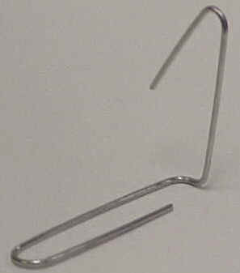
- Use the graduated cylinder to accurately measure 100g (100ml) of water. Pour this water into an uncut soft drink can.
- Place the thermometer in the uncut can and measure the water temperature after 3 minutes. Record this temperature on data table 1.
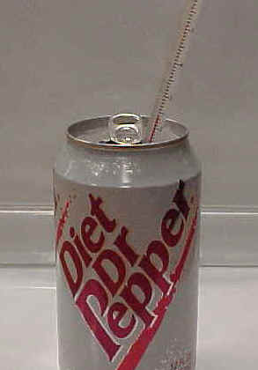
- Mass the nut (g) that you will burn and record this mass on data table 1.
- Suspend this uncut can by its tab to a metal spatula lying across an O-ring.
- Attach the nut to the bent end of your paper clip and carefully set the clip & nut into the cut-out soft drink can on bottom. Make sure the cans are sitting on a flat, nonflammable surface!

- Carefully light the nut from the bottom using a match and record the change in water temperature as the nut burns (thermometer in the can during burning). Immediately after the nut finishes burning, record the final (highest) water temperature on data table 1.
- Measure the mass (g) of the remaining nut & record this in the data table 1. (Mass the burned nut and paper clip together and then subtract the mass of the nut to get the mass of the nut alone.)
- Complete the data table1 by calculating the change in mass of the nut.
- Repeat this experiment with the other two types of nuts .
- When all three nuts have been burned, complete the analysis on data table 2.

Results:

Table 1 - Results of Burning
 | PECAN | WALNUT | ALMOND
ºC H₂O temperature Before burning
ºC
ºC H₂O temperature After burning
ºC
Difference in ºC H₂O temperature
ºC
Mass of Paper Clip
g
Mass of Nut Before Burning
Mass of Paper Clip and Nut After Burning
g
Mass of Nut ALONE After Burning
(Subtract paper clip mass from mass of nut & paper clip after burning)
g (Subtract paper clip mass from mass of nut & paper clip after burning)
g

Table 2 - Data Analysis from Nut Calorimetry
 | PECAN | WALNUT | ALMOND
Mass Difference of Nut Before & After Burning
(Subtract mass of nut after burning from Mass of nut before burning)
g
Temperature Difference of H₂O Before & After Burning
(Subtract original water temp. from final water temp.)
ºC
Calories Required to Change the Temperature of 100 g of H₂O
(Multiply temperature change by 100)
Cal
Average Calories per gram in the Nut
(Divide the total calories by the mass difference of the nut before & after burning)
Cal/g
Average kilocalories or food calories per gram
(Divide the calories per gram by 1000)
kcal/g

Questions & Conclusion:
- Where did the energy stored in the nut originally come from?
- During what process was this energy stored in the nut, & where specifically was it stored?
- What simple sugar made by plants is a common source for stored energy?
- Which group of macromolecules would a nut contain --- carbohydrates, lipids, or protein?
- What is the name for stored energy?
- Give some examples of how organisms would use this stored energy.
- In this experiment, discuss what happened to the energy stored in the nut.
- Why was the final mass of the nut less than the original mass of the nut? (Remember that matter can't be destroyed in a chemical reaction.)

