Acids and Bases
The degree of acidity or alkalinity (basic) is important in organisms. The body must constantly maintain a near neutral pH (7) in the blood and body tissues. To do this, the body produces buffers that can neutralize acids. Acidic and basic conditions in the body occur due to different metabolic (chemical) reactions taking place throughout the body.
- What does alkalinity mean?

- What pH must organisms maintain?

- What characteristic of life would maintaining this balance be?

- What chemicals does the body produce to keep neutral pH?

- Buffers ____________ acids in the body.

- Acidic and basic conditions occur due to _____________ reactions in the body.
Water is one of the most important molecules in the body. Cells are made mostly of water and water is required for almost every metabolic reaction in the body. The force of attraction between water molecules is so strong that the oxygen atom of one molecule can actually remove the hydrogen from other water molecules. This reaction is known as dissociation, and it takes place in our cells. Water (H₂0) dissociates into H⁺ and OH⁻ ions. A charged atom or molecule is called an ion. The OH⁻ ion is called the hydroxide ion, while the H⁺ ion is called the hydrogen ion. Free H⁺ ions can react with another water molecule to form the H₃O⁺ or hydronium ion. The human body requires a neutral pH for many reasons. One reason cells like a neutral pH is for proteins. Basic or acidic solutions denature proteins (change their shape) so they no longer work.
- What is dissociation?

- What is the chemical formula for water?

- What is an ion?

- Name the 2 ions form when water dissociates.

- What is the hydroxide ion?

- What is a hydrogen ion?

- What is the hydronium ion and its formula?
Acidity or alkalinity is a measure of the relative amount of H⁺ and OH⁻ ions dissolved in a solution. Neutral solutions have an equal number of H⁺ and OH⁻ ions. Acids have more H₃O⁺ ions (H+) than OH⁻ ions. Acids taste sour and can be corrosive. Digestive fluids in the body are acidic and must be neutralized by buffers. Bases contain more OH⁻ ions than H₃O⁺ ions. Bases taste bitter and feel slippery.
When an acid is combined with a base, neutralization occurs. The result of neutralization is a salt and water. Neutralization helps return our body pH to neutral. The process of our bodies maintaining neutral pH so that proteins can work properly without being denaturated (unfolded) is known as homeostasis.
- How do you measure for acidity or alkalinity?

- What is a neutral solution?

- Acids have more ___________ ions and taste _____________. And can be ________________.
- Bases contain more _____________ ions than ____________ ions.
- ______________ fluids are acid in the body and must be _________________ by _________________.
- Bases taste ________________ and feel __________________.
- What is neutralization?

- What 2 things are produced by neutralization?

- Neutralization keeps our pH at ________________ and is an example of maintaining ______________________.
Color the following diagrams according to the key.
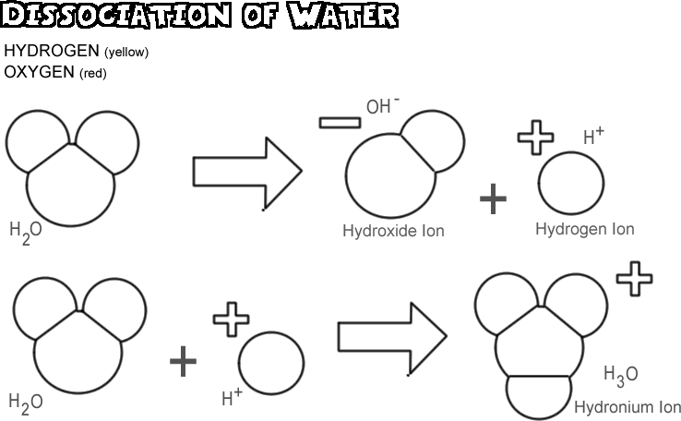

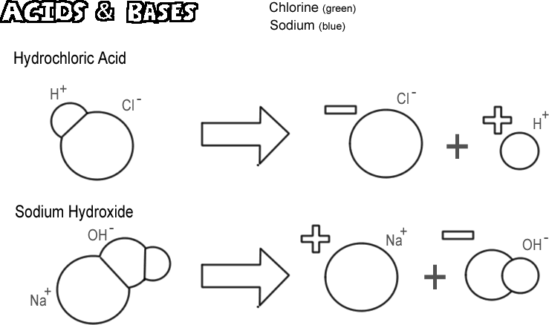
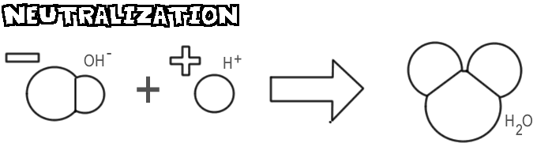Questions:
1. Why is the water molecule so important to organisms?
____________________________________________________________________________________________________________________________

2. What ions form when water dissociates?
______________________________________________________________

3. What is meant by the term alkalinity?
______________________________________________________________

4. What is produced by the body to help neutralize acidic conditions?
______________________________________________________________

5. What is the name for the OH⁻ ions?
______________________________________________________________

6. What is the name for the H⁺ ion?
_____________________________________________________________

7. How does the hydronium ion form? What is its formula?
____________________________________________________________________________________________________________________________

8. Why do most proteins need near a neutral pH?
______________________________________________________________

9. What two substances form from an acid-base neutralization?
______________________________________________________________

10. Acids have an excess of ____________ ions.

